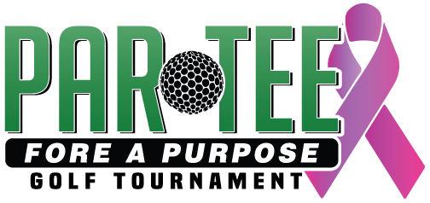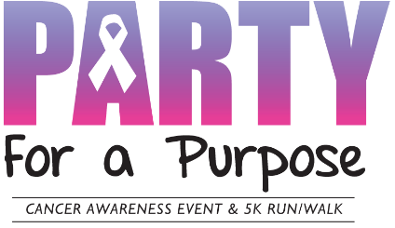
Sponsors Are Needed
Party For a Purpose Cancer Awareness Event
Par-Tee Fore a Purpose Golf on Saturday July 31st, 2021 Monticello Country Club
Golf Event Sponsorship:
Event Sponsor: $1,000 – Includes prominent advertising of your business name and logo on all marketing materials for the event. Logo on 5x7 banner prominently displayed at entrance. Limited to 2 sponsors. Free event booth space by registration at the Country Club
Gold Sponsor: $500 – Includes advertising of your business name and logo on all marketing materials for the event. Must choose Beverage Cart 1, Beverage Cart 2, T-Shirt Sponsor, Par-Tee Cart, or Master Sponsor
Beverage Carts (2)- Sign on beverage cart as it is driving around the front or the back 9 of the course during play.
SOLD T-Shirt Sponsor (1)- Your logo displayed on the sleeve of the T-Shirts that will be given away at the event.
Par-Tee Cart Sponsor (1)- 2 carts will be drawn for 1 team to drive around during the event. Carts should be decorated and filled with items for the foursome to enjoy or take home. Contact us for examples.
Master Sponsor(unlimited)-Includes sign on the course along with the above gold sponsor benefits.
Hole Sponsor: $200 (18) – includes name of company or family sponsoring on Hole. Recognition on the Golf program. If you choose to be at your hole during the event, you must make arrangements with us so that we can make sure we are complying with the Golf Course rules and regulations on giveaways.
Silent Auction: We are seeking silent auction items for our online Silent Auction. If you can donate something, please drop off at 301 Chelsea Rd or let us know and we can pick up items.
.
YES! We support Party for a Purpose –
Business or Individual’s Name _______________________________________________________________
Contact Person: ___________________________________
Ph. ___________________________________
Email: ___________________________________________________ Check#_______________
Please indicate your level of sponsorship: Pymnt. Enclosed: _______________
Event Sponsor: $1000 Gold Sponsor: $500 Hole Sponsor: $250 (Please circle or highlight response)
Other: $ ______
Feel free to list any other ways you would like to show your support: ___________________________

*Please make checks payable to Party For a Purpose Thank You!
** Please mail completed forms and payment to:
Party For A Purpose: 301 Chelsea Rd Monticello, MN 55362

We also have Venmo. @TaraThurber (Cancer Sucks Logo)

Contact info: Tara Thurber tara@allelementsinc.net 763-442-6580 or Jason Kisner jason@auscodesign.com 763-257-9282

